Unit 11: Traveling Around Viet Nam
Section : Write
- Read the first part of a story about traveling around Viet Nam.
Tuần trước, trong khi đi nghỉ ở Đà Lạt, gia đình ông bà Browns đã có một chuyến đi phiêu lưu mạo hiểm. Vào một buổi chiều họ quyết định bơi thuyền quanh hồ Xuân Hương trên một chiếc ca nô. Sau khi thuê ca nô, cả gia đình bước xuống thuyền và bơi ra giữa hồ. Thật không may, mây đen kéo đến và trời đổ mưa.
1. Now, put the sentences below in the correct chronological order to complete the story.
Thứ tự là: c -> a -> g -> d -> f -> b -> e. Chúng ta được câu chuyện:
c) The wind started to blow and the rain became heavier.
a) The canoe moved up and down the water.
g) Shannon dropped her paddle.
d) She leaned over and tried to pick it up.
f) The canoe overturned and everyone fell into the deep and dangerous water.
b) A boat appeared and rescued them.
e) The family was very lucky.
2. Put the events below in the correct chronological order and write the story. Start with the sentence below.
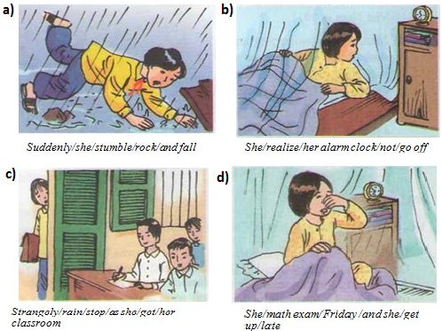
Uyen had a day to remember last week.
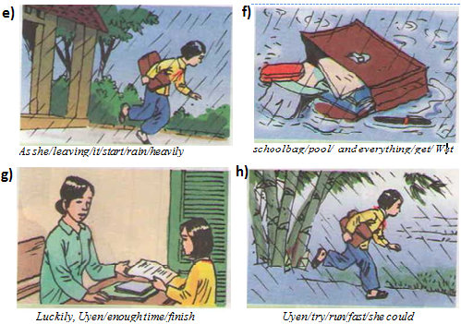
Trật tự tranh: d -> b-> e-> h-> a-> f-> c-> g
Câu chuyện gợi ý:
Uyen had a day to remember last week. She had a math exam last Friday, so she had to stay up late the night before to do her exercises. She got up late the next morning. She realized that her alarm clock didn't go off. As she was leaving, it started to rain heavily. Uyen tried to run as fast as she could. Suddenly she stumbled over a rock and fell down. Her schoolbag dropped into a pool and everything got wet. The rain stopped as she got to the classroom. Luckily, Uyen had enough time to finish her exam.

